Streaming Analytics

You are appointed as a Streaming Analytics expert for a firm which is looking for utilizing the solutions / platforms available from the Streaming Analytics space. As the firms maturity level in the big data space is at very nascent stage, you need to help them to understand how Streaming Analytics is helpful in their several use cases and also further on identifying the various options of tools and platforms those can be leveraged for this activity.

Amazon Web Service (AWS) is leading player in the space of cloud computing. They have developed a special cloud service named “Amazon Kinesis” exclusively for handling various streaming analytics use cases in very simpler manner. To introduce these services to the world, they also have prepared a nice documentation – part of which also contains the white paper. You can refer to this white paper which can help you while interacting with the client.

Q1. You need to introduce the client with several examples where streaming analytics has already been used. For that purpose, you need to formulate one example of each type of Real-time application scenarios mentioned in the white paper.
- The example should be different from the ones discussed in the document
- Narration should have
  - brief description of the use case scenario
  - short explanation about how it can leverage streaming analytics solutions / platforms
  - justification about how it falls under the particular category
[3 Marks]

Q2. You are in a meeting with the firm’s management who are little bit concerned about the challenges associated with streaming analytics. The white paper describes few challenges faced while adapting the streaming analytics. In order to assist the client
- Briefly narrate the four critical challenges in your own words
- Identify the different tools that can be used to resolve / mitigate those challenges
- Address how each of the challenge is resolved with the tools / platforms identified
[2 Marks]

Q3. The white paper discusses three different use cases which the toll station company has addressed using streaming data. But the solution is described in terms of various cloud services offered by AWS. The client does not have the knowledge about the cloud computing and AWS. In fact all the three use cases can be very well addressed with a general architecture used in the big data analytics and streaming analytics. You need to work upon helping client to understand those common architectures.
- Identify the architecture that can be fitted well for capturing all three use cases
- Convert the final architecture diagram provided by AWS team into an architecture diagram based upon your answer to earlier question
- Take care that all three cases should be vividly coming out of the architecture diagram, if required add brief description about each flow
[3 Marks]

Q4. The client is now impressed with the capabilities of the AWS and how it’s streamlining the application development and deployment. But they also want to discover more on the open source tools / platforms that can be leveraged. As a result, you need to work upon identifying the open source tools for each of the use case.
- For each of the use case
  - Identify the tools / platforms that can be used to solve it
  - Draw a solution diagram using the tools identified in earlier question the flow should come out clearly from the solution diagram
[2 Marks]

***********

Here are the answers to the four questions based on the document:

Q1. Examples of Real-Time Application Scenarios
- Evolving from Batch to Streaming Analytics:
  - Example: A retail chain uses streaming analytics to monitor inventory in near real-time across multiple stores. Data from barcode scanners is streamed to a central system, identifying low-stock items instantly and triggering automatic reordering.
  - How it leverages streaming analytics: By processing data as it arrives, the system ensures inventory data is always up-to-date.
  - Justification: This fits the "Evolving from Batch to Streaming Analytics" category as it replaces traditional batch inventory checks with continuous data streams for timely decision-making.
- Building Real-Time Applications:
  - Example: An online gaming platform uses streaming analytics to update player leaderboards in real-time. It ingests gameplay data, calculates scores instantly, and updates the leaderboard visible to all players.
  - How it leverages streaming analytics: Real-time ingestion and processing of gameplay data ensure instant feedback to players.
  - Justification: This falls under "Building Real-Time Applications" due to the need for millisecond latency to enhance user experience.

Q2. Challenges in Streaming Analytics
- High Throughput and Low Latency Requirements:
  - Challenge: Handling millions of events per second with minimal delays is complex.
  - Tool/Platform: Apache Kafka can manage high-throughput streams efficiently.
  - Resolution: Kafka’s partitioning and replication ensure scalability and fault tolerance, meeting performance demands.
- Ensuring Data Consistency:
  - Challenge: Processing data consistently across distributed systems is challenging.
  - Tool/Platform: Apache Flink provides exactly-once processing guarantees.
  - Resolution: Flink’s state management ensures data consistency across streaming jobs.
- Data Integration from Multiple Sources:
  - Challenge: Combining data from diverse sources in real-time is cumbersome.
  - Tool/Platform: Apache NiFi simplifies data flow integration.
  - Resolution: NiFi provides a visual interface and pre-built connectors for seamless integration.
- Monitoring and Fault Tolerance:
  - Challenge: Ensuring the system runs smoothly without losing data during failures.
  - Tool/Platform: Apache Storm with Zookeeper ensures fault tolerance.
  - Resolution: Automatic failover and checkpointing mechanisms recover from failures seamlessly.

Q3. Generalized Architecture for Toll Station Use Cases
- Architecture Identification:
  - A generalized streaming architecture using Apache Kafka (data ingestion), Apache Flink (processing), and HDFS/S3 (data storage) can handle the three use cases:
    - Real-time data loading to the warehouse: Kafka to stream data, Flink for transformations, and S3 for storage.
    - Billing threshold alerts: Flink for aggregations, Kafka for data streams, and custom alerts via email/SMS tools.
    - Vehicle traffic monitoring: Flink for comparing vehicle counts with thresholds and generating alerts.
- Architecture Diagram:
  - A flow diagram can be drawn with Kafka for ingestion, Flink for processing/alerts, S3 for storage, and user applications for notifications and insights.

Q4. Open-Source Tools for Use Cases
- Real-Time Data Loading to Warehouse:
  - Tool/Platform: Apache Kafka for ingestion, Apache Hudi for real-time updates in data lakes.
  - Solution Diagram: Kafka ingests data -> Hudi stores updates -> BI tools query the updated data.
- Billing Threshold Alerts:
  - Tool/Platform: Apache Flink for real-time aggregations, Twilio for sending notifications.
  - Solution Diagram: Kafka streams -> Flink aggregates -> Twilio sends alerts.
- Vehicle Traffic Monitoring:
  - Tool/Platform: Apache Flink for processing, Elasticsearch for monitoring and Kibana for visualization.
  - Solution Diagram: Kafka streams -> Flink processes -> Elasticsearch indexes -> Kibana visualizes.

Stream processing and Analytics
Assignment 2 – Data Processing with Apache Kafka
Submission Date: 30 April 2024
Weightage: 20%
The number of accidents is shooting upward daily along with the rising safety concerns while travelling. A solution for most of these problems can be provided with an Intelligent Vehicle Monitoring System Using Global Positioning System along with Google Maps and Cloud Computing which collects useful information about a vehicle. There are also various sensors which relay information like fuel level, driver conditions and tire pressure. The vital information like the vehicle location, speed is gathered by the GPS which is fitted in the vehicle and transmitted in near-real-time to a centralized server maintained in the cloud network over MQTT protocol. This information is then available for the authorized users in real time and each licensed vehicle owner can access the data in cloud using a web portal anytime anywhere. This system thus provides an accurate positioning of the vehicle, speed, driver's condition and provides an intelligent monitoring of the vehicle remotely.
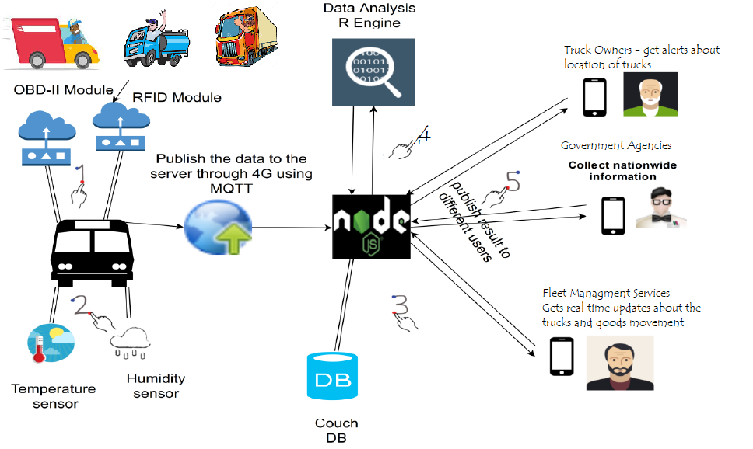

Your group is selected to prepare a working prototype of this IVMS using open source messaging platform Apache Kafka. A working prototype should mimic the following requirements -
- Capturing the real time truck movement data from the sensors fitted in the trucks
- Moving the running truck data over MQTT protocol to a centralized location
- Moving data from centralized location to messaging store for intermittent storage (may put it in the persistent storage as well)
- Preprocessing of the data received from the trucks for quality checks and for other required transformations
- Doing the processing of data to identify the drivers exceeding the speed limits
- Providing a mechanism to flag out the details of drivers exceeding the speed limits
- Providing a way to maintain the count of over speeding incidents over the period of time, on particular routes, for particular trucks etc.

You are supposed to carry out following tasks programmatically to help to roll out the solution.
Task 1: Architecture diagram for the whole solution
Task 2: Database schema and implementation for Truck driver data storage
Task 3: Simulator program for the truck data movement over the period of time
Task 4: Data Transfer program moving the data from the truck to central server like Mosquito broker through MQTT protocol
Task 5: Data transfer program from Mosquito broker to Kafka Topic and a raw data storage
Task 6: Data preprocessing / filtering program for identifying over speeding cases
Task 7: Program to keep statistics about over speeding cases over the period of time, for different routes, for different trucks etc.
Task 8: A simple interface for showing over speeding statistics to the end consumers

Here are the solutions to the tasks outlined in the document:

Task 1: Architecture Diagram
An architecture diagram should include:
- Truck Sensors: Capturing real-time data (location, speed, tire pressure, fuel levels).
- MQTT Broker: Using Mosquitto to move data to a centralized server.
- Apache Kafka: Intermediate messaging storage.
- Data Preprocessing: Filtering and transforming data.
- Speed Analysis Module: Identifying over-speeding cases.
- Persistent Storage: Storing data in a database for analytics.
- Dashboard: Visualizing statistics for users.
Diagram elements will flow as follows:
- Sensors → MQTT Broker → Kafka → Data Preprocessing → Analysis → Persistent Storage & Dashboard.

Task 2: Database Schema
A schema for storing truck and driver data:
CREATE TABLE Drivers (
DriverID INT PRIMARY KEY,
Name VARCHAR(100),
LicenseNumber VARCHAR(50),
TruckID INT,
Route VARCHAR(100)
);

CREATE TABLE Trucks (
TruckID INT PRIMARY KEY,
TruckModel VARCHAR(100),
MaxSpeed INT,
CurrentLocation VARCHAR(100)
);

CREATE TABLE SpeedViolations (
ViolationID INT PRIMARY KEY,
DriverID INT,
TruckID INT,
Route VARCHAR(100),
Timestamp DATETIME,
Speed INT,
FOREIGN KEY (DriverID) REFERENCES Drivers(DriverID),
FOREIGN KEY (TruckID) REFERENCES Trucks(TruckID)
);

Task 3: Simulator Program
A Python program to simulate truck data:
import random
import time
import json

def generate_truck_data():
trucks = ['TruckA', 'TruckB', 'TruckC']
routes = ['Route1', 'Route2', 'Route3']

while True:
data = {
"TruckID": random.choice(trucks),
"Route": random.choice(routes),
"Speed": random.randint(40, 120),
"FuelLevel": random.randint(10, 100),
"DriverID": random.randint(1, 10)
}
print(json.dumps(data)) # Replace with MQTT publish logic
time.sleep(1)

generate_truck_data()

Task 4: MQTT Data Transfer
Use the Paho MQTT client for data transfer:
import paho.mqtt.client as mqtt
import json

def publish_data():
broker = "mqtt.eclipse.org"
port = 1883
topic = "truck/data"

client = mqtt.Client()
client.connect(broker, port)

data = {
"TruckID": "TruckA",
"Speed": 85,
"FuelLevel": 60
}
client.publish(topic, json.dumps(data))

publish_data()

Task 5: Data Transfer from MQTT to Kafka
Use the Kafka Python library:
from kafka import KafkaProducer
import paho.mqtt.client as mqtt

def on_message(client, userdata, msg):
producer = KafkaProducer(bootstrap_servers='localhost:9092')
producer.send('raw_data', msg.payload)

mqtt_client = mqtt.Client()
mqtt_client.on_message = on_message
mqtt_client.connect("mqtt.eclipse.org", 1883)
mqtt_client.subscribe("truck/data")
mqtt_client.loop_forever()

Task 6: Data Preprocessing
Filter over-speeding cases:
from kafka import KafkaConsumer, KafkaProducer
import json

def process_data():
consumer = KafkaConsumer('raw_data', bootstrap_servers='localhost:9092', auto_offset_reset='earliest')
producer = KafkaProducer(bootstrap_servers='localhost:9092')

for message in consumer:
data = json.loads(message.value)
if data['Speed'] > 80: # Assuming 80 km/h is the speed limit
producer.send('overspeed_data', json.dumps(data).encode('utf-8'))

process_data()

Task 7: Over-Speeding Statistics
Maintain statistics using an SQLite database:
import sqlite3

def store_violation(data):
conn = sqlite3.connect('violations.db')
cursor = conn.cursor()
cursor.execute('''CREATE TABLE IF NOT EXISTS Violations
(DriverID INT, TruckID TEXT, Speed INT, Timestamp DATETIME)''')
cursor.execute("INSERT INTO Violations VALUES (?, ?, ?, datetime('now'))",
(data['DriverID'], data['TruckID'], data['Speed']))
conn.commit()
conn.close()

Task 8: Statistics Interface
A simple Flask app for displaying statistics:
from flask import Flask, jsonify
import sqlite3

app = Flask(__name__)

@app.route('/violations', methods=['GET'])
def get_violations():
conn = sqlite3.connect('violations.db')
cursor = conn.cursor()
cursor.execute("SELECT * FROM Violations")
data = cursor.fetchall()
conn.close()
return jsonify(data)

app.run(debug=True)

Let me know if you need a demo video workflow or additional details!

Q1. Stream S1 has attributes “x” and “y”. Stream S2 has attributes “x” and “y”. Both streams have a common attribute “id”. The two streams are joined based on “id” attribute. Window of size 2 is mentioned on both streams. The streaming query is defined as follows -

Select s1.x % 3, s2.y % 4
From S1 as s1 join S2 as s2
On s1.id = s2.id

Provide the outcomes of the joins with each step of the execution. (Pictorial representation is must). [10]

Stream S1
Time | Event | Id | X | y
T1 | E1 | 0 | 3 | 5
T2 | E3 | 1 | 6 | 8
T5 | E5 | 2 | 4 | 3
T6 | E6 | 3 | 7 | 3
T9 | E7 | 4 | 15 | 3

Stream S2
Time | Event | Id | X | y
T2 | E2 | 1 | 3 | 5
T4 | E4 | 2 | 3 | 3
T7 | E7 | 3 | 4 | 8
T8 | E8 | 4 | 9 | 3
T10 | E10 | 5 | 20 | 4

Let's break down the given problem in steps and visualize the execution of the join operation on the two streams, S1 and S2, based on the common attribute id. The goal is to show the results of the join operation as well as the execution at each time step while considering the window of size 2.
Given Data:
Stream S1:
Time | Event | Id | X | Y
T1 | E1 | 0 | 3 | 5
T2 | E3 | 1 | 6 | 8
T5 | E5 | 2 | 4 | 3
T6 | E6 | 3 | 7 | 3
T9 | E7 | 4 | 15 | 3
Stream S2:
Time | Event | Id | X | Y
T2 | E2 | 1 | 3 | 5
T4 | E4 | 2 | 3 | 3
T7 | E7 | 3 | 4 | 8
T8 | E8 | 4 | 9 | 3
T10 | E10 | 5 | 20 | 4
Step-by-step execution:
We will process the events from both streams and apply the window join of size 2. This means that, at any given time, we will consider only the last two events in the window.
Join Conditions:
- We are performing an inner join on the id field.
- We also need to compute the following for the joined pairs:
  - s1.x % 3
  - s2.y % 4
Windowing Consideration:
- For a window size of 2, at any given time t, the window includes events from the last two timestamps (from both S1 and S2).
Execution Walkthrough:
At Time T1 (Stream S1):
- Only event T1 is present from stream S1. No matching event from S2 because the first event from S2 appears only at T2. Thus, no join can happen at this moment.
At Time T2 (Stream S1 and S2):
- Stream S1 adds event T2 (id = 1), and Stream S2 adds event T2 (id = 1).
- Join Condition: s1.id = s2.id → 1 = 1
- Join Result:
  - s1.x % 3 = 6 % 3 = 0
  - s2.y % 4 = 5 % 4 = 1
- Joined Output: (0, 1)
At Time T4 (Stream S2):
- Event T4 from stream S2 arrives (id = 2), and stream S1 still has events from T1 and T2 in its window. But, no match with stream S1 (id from S1 are 0 and 1, not 2).
- No join occurs at this point.
At Time T5 (Stream S1):
- Stream S1 adds event T5 (id = 2).
- Join Condition: s1.id = s2.id → 2 = 2 (Match found).
- Join Result:
  - s1.x % 3 = 4 % 3 = 1
  - s2.y % 4 = 3 % 4 = 3
- Joined Output: (1, 3)
At Time T6 (Stream S1):
- Event T6 from stream S1 arrives (id = 3).
- Join Condition: s1.id = s2.id → 3 = 3
- Join Result:
  - s1.x % 3 = 7 % 3 = 1
  - s2.y % 4 = 8 % 4 = 0
- Joined Output: (1, 0)
At Time T7 (Stream S2):
- Event T7 from stream S2 arrives (id = 3).
- Join Condition: s1.id = s2.id → 3 = 3
- Join Result:
  - s1.x % 3 = 7 % 3 = 1
  - s2.y % 4 = 8 % 4 = 0
- Joined Output: (1, 0)
At Time T8 (Stream S2):
- Event T8 from stream S2 arrives (id = 4), and stream S1 now has events T5, T6, and T9 in its window.
- Join Condition: s1.id = s2.id → 4 = 4 (Match found).
- Join Result:
  - s1.x % 3 = 15 % 3 = 0
  - s2.y % 4 = 3 % 4 = 3
- Joined Output: (0, 3)
At Time T9 (Stream S1):
- Event T9 from stream S1 arrives (id = 4).
- Join Condition: s1.id = s2.id → 4 = 4
- Join Result:
  - s1.x % 3 = 15 % 3 = 0
  - s2.y % 4 = 3 % 4 = 3
- Joined Output: (0, 3)
At Time T10 (Stream S2):
- Event T10 from stream S2 arrives (id = 5). No corresponding event from stream S1 in the last two timestamps (T6, T9), so no join occurs at this time.

Pictorial Representation:
Window and Join Results:
Time: T1 T2 T4 T5 T6 T7 T8 T9 T10
Stream S1: E1 E3 - E5 E6 - - E7 -
Stream S2: - E2 E4 - - E7 E8 - E10

Join Results:
At T2: (0, 1) [s1.x % 3 = 6 % 3 = 0, s2.y % 4 = 5 % 4 = 1]
At T5: (1, 3) [s1.x % 3 = 4 % 3 = 1, s2.y % 4 = 3 % 4 = 3]
At T6: (1, 0) [s1.x % 3 = 7 % 3 = 1, s2.y % 4 = 8 % 4 = 0]
At T7: (1, 0) [s1.x % 3 = 7 % 3 = 1, s2.y % 4 = 8 % 4 = 0]
At T8: (0, 3) [s1.x % 3 = 15 % 3 = 0, s2.y % 4 = 3 % 4 = 3]
At T9: (0, 3) [s1.x % 3 = 15 % 3 = 0, s2.y % 4 = 3 % 4 = 3]
Summary:
- Window Size: The window size of 2 ensures that only the last two events from both streams are considered for each join.
- Join Outputs: The final outputs are pairs of (s1.x % 3, s2.y % 4) for matching ids at each time t.

Q2. Consider the following stream of tweets for the IPL and FIFAWorldCup (FWC) released recently. Determine the trending event using the appropriate technique discussed in the class. Initial weight is 2.5 and constant factor as 0.03. [5]

Event stream – FWC, IPL, IPL, FWC, FWC, IPL, FWC, IPL, IPL, FWC

Q.3. Write pseudo code for the streaming version of algorithm to compute the range of data values from the given stream of data elements. Show its execution for the data values – 2, 4, 1, 0, -4, 3, -5, 2, 1, 0, -4 and 0. [5]

To compute the range of data values from a given stream of data elements, we can maintain two key variables during the stream processing:
- Maximum value (max): The largest value encountered so far in the stream.
- Minimum value (min): The smallest value encountered so far in the stream.
The range is then simply the difference between the maximum and minimum values:
Range=max−min\text{Range} = \text{max} - \text{min}
Pseudo Code:
Initialize min to positive infinity
Initialize max to negative infinity

For each incoming data element in the stream:
Update min if the element is smaller than the current min
Update max if the element is larger than the current max

After processing each element:
Calculate the range as: range = max - min
Output the current range
Execution for the Data Stream:
Given stream data: 2, 4, 1, 0, -4, 3, -5, 2, 1, 0, -4, 0
We'll walk through each element and update the min and max values accordingly.

Execution Steps:
Time | Data Value | min | max | Range (max - min)
1 | 2 | 2 | 2 | 0
2 | 4 | 2 | 4 | 2
3 | 1 | 1 | 4 | 3
4 | 0 | 0 | 4 | 4
5 | -4 | -4 | 4 | 8
6 | 3 | -4 | 4 | 8
7 | -5 | -5 | 4 | 9
8 | 2 | -5 | 4 | 9
9 | 1 | -5 | 4 | 9
10 | 0 | -5 | 4 | 9
11 | -4 | -5 | 4 | 9
12 | 0 | -5 | 4 | 9
Explanation of Each Step:
- First value (2): The initial values of min and max are set to 2, as it's the first element. Range = max - min = 2 - 2 = 0.
- Second value (4): The new value 4 updates the max to 4, while min remains 2. Range = max - min = 4 - 2 = 2.
- Third value (1): The new value 1 updates min to 1, while max remains 4. Range = max - min = 4 - 1 = 3.
- Fourth value (0): The new value 0 updates min to 0, while max remains 4. Range = max - min = 4 - 0 = 4.
- Fifth value (-4): The new value -4 updates min to -4, while max remains 4. Range = max - min = 4 - (-4) = 8.
- Sixth value (3): The new value 3 doesn't change min or max. Range = max - min = 4 - (-4) = 8.
- Seventh value (-5): The new value -5 updates min to -5, while max remains 4. Range = max - min = 4 - (-5) = 9.
- Eighth value (2): The new value 2 doesn't change min or max. Range = max - min = 4 - (-5) = 9.
- Ninth value (1): The new value 1 doesn't change min or max. Range = max - min = 4 - (-5) = 9.
- Tenth value (0): The new value 0 doesn't change min or max. Range = max - min = 4 - (-5) = 9.
- Eleventh value (-4): The new value -4 doesn't change min or max. Range = max - min = 4 - (-5) = 9.
- Twelfth value (0): The new value 0 doesn't change min or max. Range = max - min = 4 - (-5) = 9.

Conclusion:
- At the end of the stream, the min value is -5, the max value is 4, and the range is 4−(−5)=94 - (-5) = 9.
This approach works in real-time streaming, and the range is updated as new data arrives.

Q.4. Answer the following Bloom Filter design sub questions – [3 + 2 + 1 + 2 + 2 = 10]
You are appointed as a data engineer require to propose a searching mechanism based on Blooms filter. For this Bloom filters False Positivity rate is given by the formula

(1 – exp ( -nk/m ) )^{k}

Where m represents number of elements in the stream under consideration, n is actual storage capacity of the filter and k is number of hash functions used.

The filter capacity estimated to be 6 MB. Over period of time the filter could store 10⁶ events using 3 hash functions

- Estimate the false positive rate of the filter with given parameters.
- What is the False Positivity rate if filter capacity is changed to 60 MB, keeping other parameters same?
- What can be the conclusion drawn from part (a) and (b) above?
- If optimal number of hash functions is given by following formula, what is optimal number of hash functions needed to build this Bloom filter?
k_{opt} = (m/n) ln2
- What is the main disadvantage of this filter design in part (d)? How do we correct it?

Here is the text you can copy into a Word document, including the formulae:

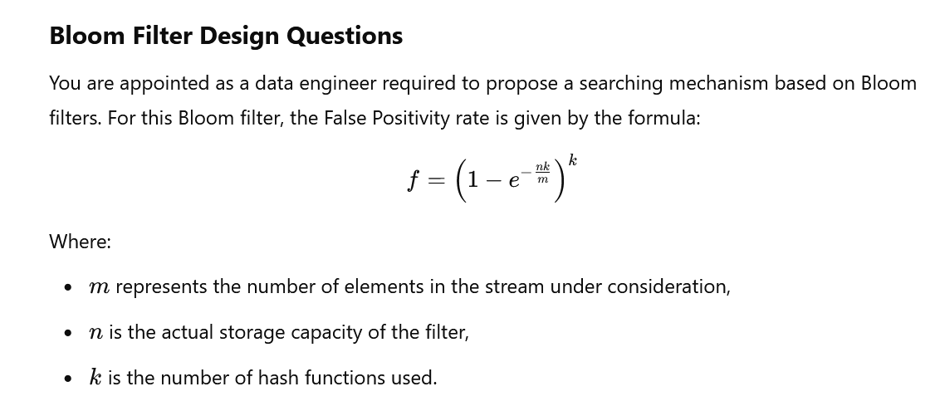The filter capacity is estimated to be 6 MB. Over time, the filter could store 1,000,000 events using 3 hash functions.

a) Estimate the False Positive Rate for the Filter with Given Parameters (6 MB Capacity)
Given:
- Number of events in the stream m=1,000,000m = 1,000,000,
- Storage capacity n=6 MB=6×8×1024×1024=50,331,648 bitsn = 6 \, \text{MB} = 6 \times 8 \times 1024 \times 1024 = 50,331,648 \, \text{bits},
- Number of hash functions k=3k = 3.
Substitute these values into the formula:
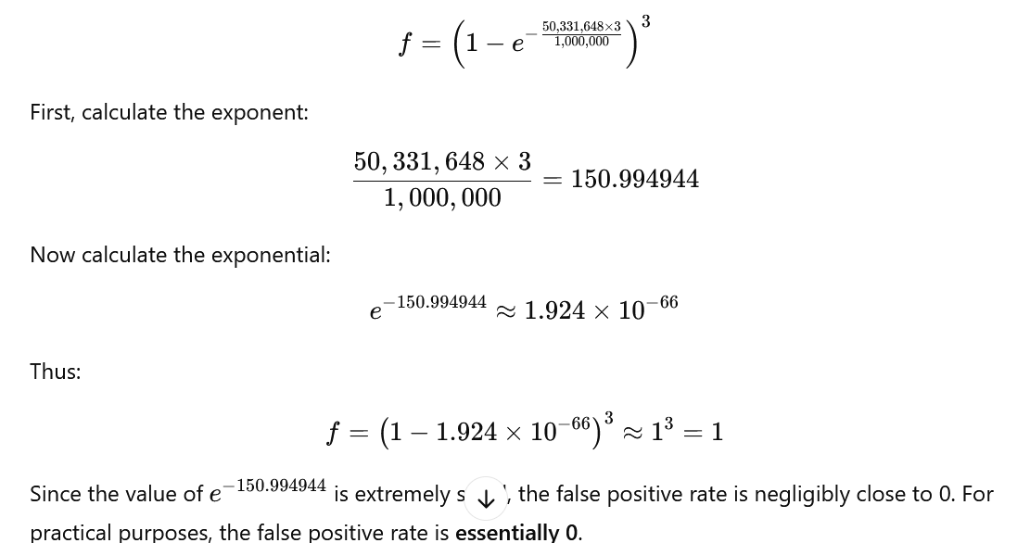Since the value of e−150.994944e^{-150.994944} is extremely small, the false positive rate is negligibly close to 0. For practical purposes, the false positive rate is essentially 0.

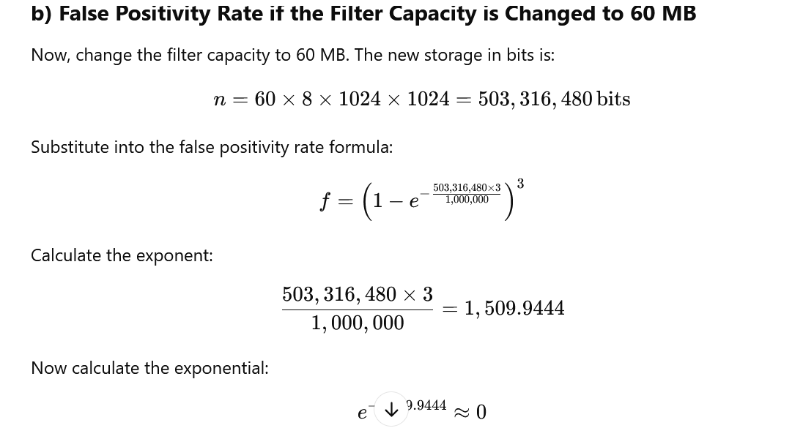Thus:
f=(1−0)3=1f = \left(1 - 0\right)^3 = 1
With 60 MB of capacity, the false positivity rate is still negligibly close to 0, similar to part (a). Therefore, the false positive rate remains effectively 0 in both cases.

c) Conclusion from Parts (a) and (b)
From the calculations in both parts (a) and (b), we can conclude that:
- Even with a drastic increase in filter size (from 6 MB to 60 MB), the false positive rate remains close to 0.
- This suggests that Bloom filters are highly effective in these scenarios where the false positive rate is a primary concern.
- Bloom filters scale well as filter capacity increases, and the size of the filter directly influences the error rate.

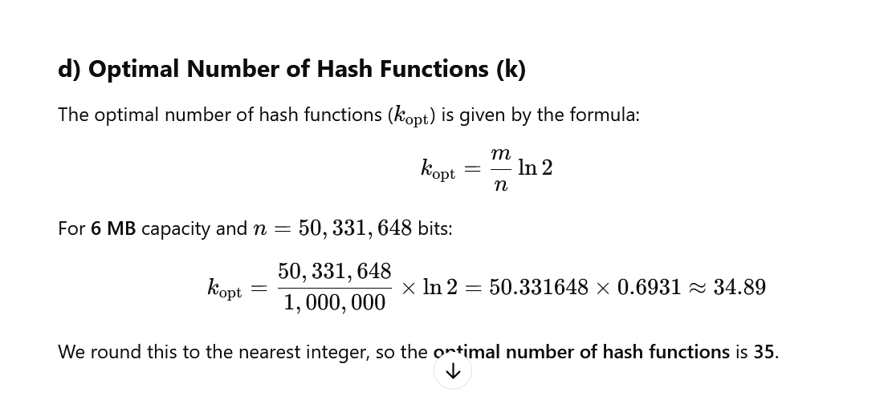
e) Main Disadvantage of the Filter Design in (d) and How to Correct It
Disadvantage: The main disadvantage of using the optimal number of hash functions (35 in this case) is that if the filter is overestimated, it can result in inefficiency. This happens because the filter might use more memory and computational resources than required, especially if the filter is designed for a smaller dataset or if the error rate is too low for the required precision.
Correction: To correct this, we can:
- Balance memory and hash functions: Tune the number of hash functions based on the actual data stream and expected false positive rate.
- Dynamic tuning: Instead of fixing the number of hash functions upfront, allow dynamic adjustment based on memory availability, filter size, or performance benchmarks.

This text contains all the necessary calculations, formulae, and explanations to present your answers clearly in a Word document.

Q5 Rishkesh’s business owns thousands of Coke vending machines and would like to make them social. He wants his machines to tweet and sent push notifications with special offers to consumers who are geographically close. If the closest vending machine doesn’t have stock to offer, it should recommend the next closest vending machine that can offer the consumer a deal. [4]

- What would happen if link between collection tier and analysis tier is interrupted for an extended period of time? How it can be mitigated? [2]
- Would you anticipate need to store historical data? Why? [1]
- What type of message delivery semantics does this streaming system needs? [1]

a) What would happen if the link between the collection tier and the analysis tier is interrupted for an extended period of time? How can it be mitigated?
If the link between the collection tier (which gathers data from the vending machines) and the analysis tier (where the data is processed and analyzed) is interrupted for an extended period of time, the following consequences may occur:
- Data Loss: If the data is not buffered or stored temporarily, some critical data related to the status of vending machines (e.g., stock levels, user interactions) may be lost. This would hinder the ability to provide consumers with accurate information about machine availability or offers.
- Processing Delays: The analysis tier will not receive updates, causing delays in processing. This would affect the ability to generate real-time offers or promotions, potentially reducing customer satisfaction or missing opportunities for real-time interactions.
- Inaccurate Recommendations: Without timely data from the collection tier, the recommendation system for offering deals from nearby vending machines would become outdated, leading to customers being offered deals from machines that no longer have the stock or aren't geographically close anymore.
Mitigation:
- Buffering or Caching: The collection tier can buffer the data temporarily on a local storage medium (like in-memory or disk) until the connection is restored. This ensures that no data is lost while the connection is down.
- Event Sourcing: This involves capturing all changes in the vending machines' state (e.g., stock updates, new offers) as events that can be processed when the system reconnects, ensuring no data loss.
- Message Queuing: Use a message queuing system (like Kafka, RabbitMQ) to hold messages during the network outage. When the link is restored, messages can be processed from the queue to ensure continuity of service.

b) Would you anticipate the need to store historical data? Why?
Yes, historical data storage would likely be necessary for the following reasons:
- Trend Analysis: Storing historical data allows for trend analysis, such as identifying popular vending machines, peak consumption times, and seasonal variations in customer preferences. This helps in optimizing stock levels and offering more personalized promotions.
- Offer Personalization: Historical data on previous customer interactions (e.g., previous offers consumed, preferences) can be used to create more effective, targeted promotions for users in the future.
- System Recovery: In case of a failure or interruption in service, having historical data ensures that the system can recover quickly by recalculating any missed transactions or events.

c) What type of message delivery semantics does this streaming system need?
The streaming system needs "at least once" message delivery semantics. This means that each message or event (e.g., data on vending machine status or user interactions) should be processed at least once, ensuring that no important information is missed, even if temporary failures or interruptions occur.
- Why "at least once": Given that vending machine statuses are critical to offering real-time deals, it's more important to ensure that every event is processed, even if it means potentially processing the same event multiple times. This ensures accuracy in recommending the correct vending machine based on real-time data, even if some events need to be reprocessed.

Q6 Assume the Apache Kafka cluster setup described by the output of following commands. [1 +1 + 1 + 2 + 1 = 6]

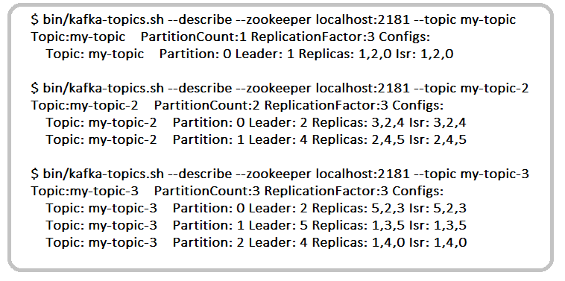
a) How many brokers are present in this system? What are their names?
b) Is it mandatory that all these brokers should reside on separate physical machines? Explain briefly.
c) For topic my-topic-3, what is the maximum number of server failures that this setup can handle?
d) For a topic my-topic-4, what is maximum and minimum number of additional copies of messages can be maintained on this cluster setup with partition count as 1?
e) How many consumer groups can be created for this configuration?
Here are the answers based on the given Kafka cluster setup:

a) How many brokers are present in this system? What are their names?
The brokers are identified by the replica and ISR (In-Sync Replica) lists across the topics:
- For my-topic, brokers are 0, 1, and 2.
- For my-topic-2, brokers are 2, 3, 4, and 5.
- For my-topic-3, brokers are 1, 2, 3, 4, and 5.
Total brokers: 6 brokers (0, 1, 2, 3, 4, and 5).

b) Is it mandatory that all these brokers should reside on separate physical machines?
No, it is not mandatory for all brokers to reside on separate physical machines. Kafka brokers can be deployed on the same machine, but it is recommended to use separate machines to:
- Improve fault tolerance: If a machine fails, it affects all brokers on that machine.
- Enhance performance: Brokers on separate machines reduce resource contention (CPU, memory, disk).

c) For topic my-topic-3, what is the maximum number of server failures that this setup can handle?
Topic my-topic-3 has a replication factor of 3, meaning each partition has 3 replicas. The maximum number of server failures it can handle is one less than the replication factor:
Maximum server failures tolerated: 2 failures (as at least one replica must remain active).

d) For topic my-topic-4, what is the maximum and minimum number of additional copies of messages that can be maintained on this cluster setup with partition count as 1?
- Maximum additional copies: Kafka's replication factor is limited by the number of brokers. With 6 brokers, a replication factor of 6 is possible, so:
  - Maximum additional copies = Replication Factor - 1 = 6 - 1 = 5.
- Minimum additional copies: At least one replica is needed (the leader), so the minimum replication factor is 1:
  - Minimum additional copies = Replication Factor - 1 = 1 - 1 = 0.

e) How many consumer groups can be created for this configuration?
Kafka allows unlimited consumer groups, but the number of effective consumers in each group for a topic is limited by the number of partitions. For example:
- Topic my-topic has 1 partition: 1 active consumer per group.
- Topic my-topic-2 has 2 partitions: 2 active consumers per group.
- Topic my-topic-3 has 3 partitions: 3 active consumers per group.
Number of consumer groups: Unlimited, but each group will only process messages from as many consumers as the number of partitions.

Let me know if you have further questions!

****************************

